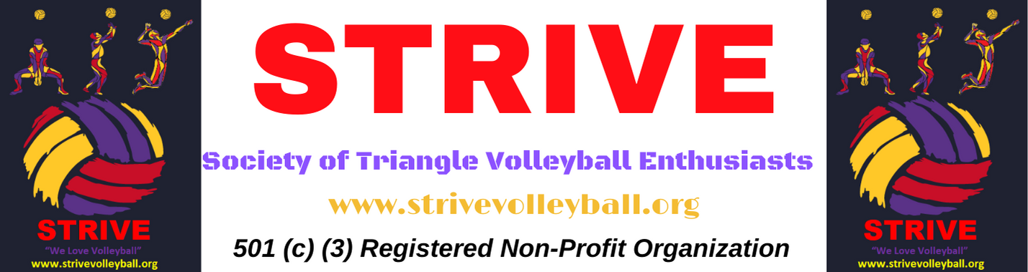

***STRIVE BUMP N’ JUMP 2022 - Volleyball Rules***

**Players**

1. A team can have a maximum of 8 players, but no more than 6 players on court and no less than 4 players on the court at any given time.
2. No person may play on more than one team. This violation will result in forfeiting of the match and multiple violations of this rule will result elimination of the team from the tournament.
3. Should be at least 13 years old and should individually consent to abide by the tournament rules as well as the volleyball game rules.

**Rules**

1. Before the ball is served, each player must be in their designated area, and in proper rotation.
2. A team must rotate one position prior to every serve (even on the first service break).
3. Substitution will be a ‘Player to Player’ substitution, i.e., the same player will substitute with the other player for the entire game. He will not be allowed to substitute for any other player on the team, except in case of a player being injured.
4. There is no limit to number of substitutions (abiding above rule# 3).
5. Libero is allowed
6. Libero is only allowed to serve at 1 rotation position
7. Libero is not allowed to attack from anywhere in the court
8. Libero cannot hand set a ball while in front of the ten-foot line
9. Players may only hit the ball on their side of the net. A player may not attack a ball that has not yet crossed the vertical plane of the net on either the first or second hit, provided that neither of these hits were attacks.
10. No serve may be blocked or attacked.
11. A legal hit is a slap or bounce type action. There must be no prolonged contact.
12. Players are permitted to penetrate the opponent’s space under the net, if this does not interfere with the opponents play.
13. Contact with the net by a player IS A FAULT. When the ball is driven into the net and causes it to touch an opponent, no fault is committed.
14. The ball may touch any part of the body.
15. Player must toss the ball for the serve.
16. A player may only have one toss per serve attempt.
17. The referee shall whistle to stop the ongoing rally. Players should continue to play the ball until/unless they hear the referee whistle to stop play.
18. If for unforeseen circumstances we must postpone a game, it will be rescheduled the following day subject to availability of courts.
19. Referee’s decision is final and binding on both the teams – in clear cut calls as well as any grey areas. The Referee may call for a replay in close cases where he is unable to decide. The captain may remind the referee about any specific lapses in rules enforcement, so referee is aware for further play.
20. The team captain is responsible for discipline and proper conduct of team members and is the only player who may address the referees and shall be the spokesperson of his/her team.
21. Referee and STRIVE organizing committee reserve the right to evict any player/team for unsportsmanlike conduct of any nature.

**­­­­­­**